Assignment 5

Open Shortest Path First (OSPF)

By Ziming Song

[zs2815@nyu.edu](mailto:zs2815@nyu.edu)

## **Screenshot configurations of R1, R2, R3, and R4.**

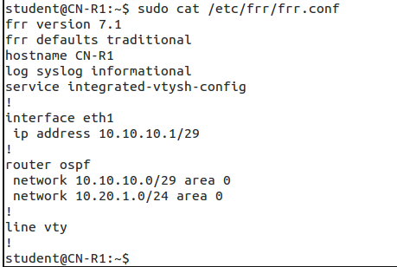

Screenshot configurations of R1

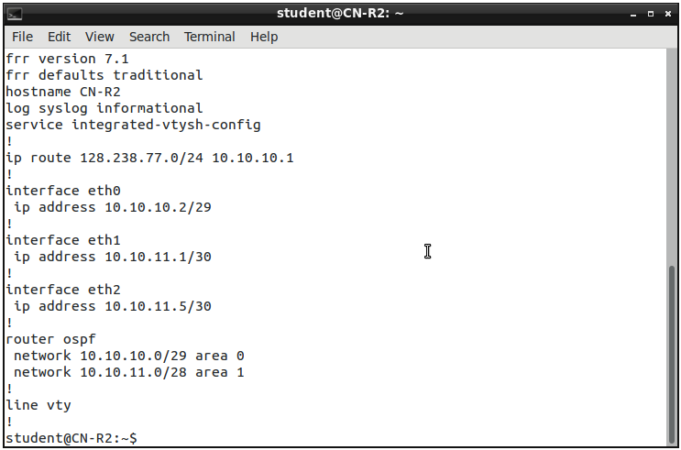

Screenshot configurations of R2

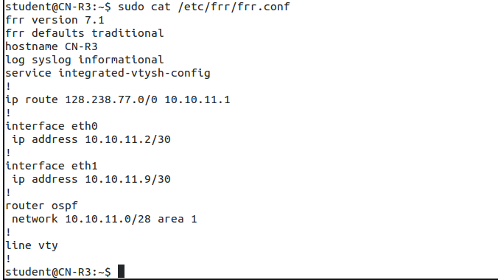Screenshot configurations of R3

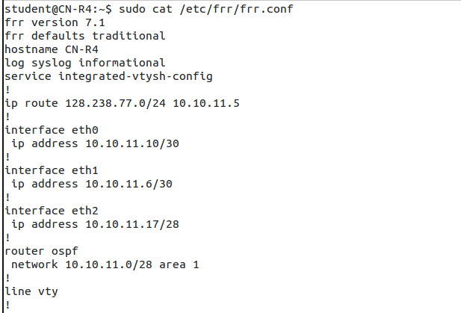

Screenshot configurations of R4

## **ICMP results from R3 to R1.**

Ping R1 from R3

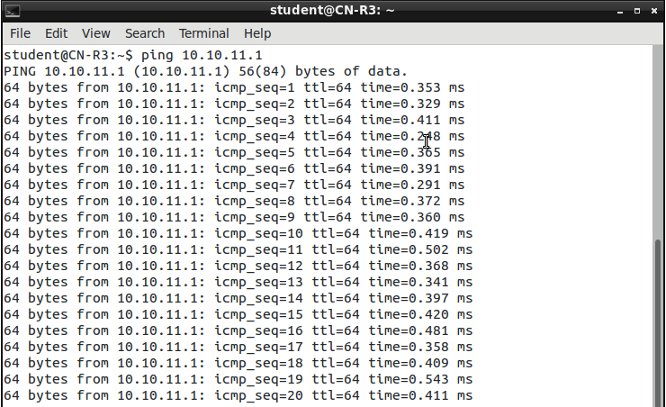

Wireshark on R3

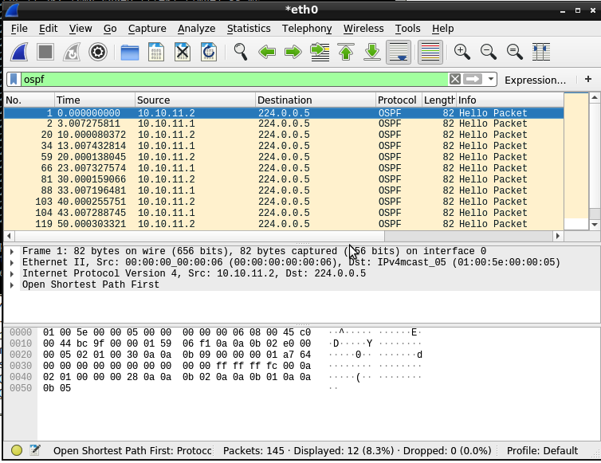

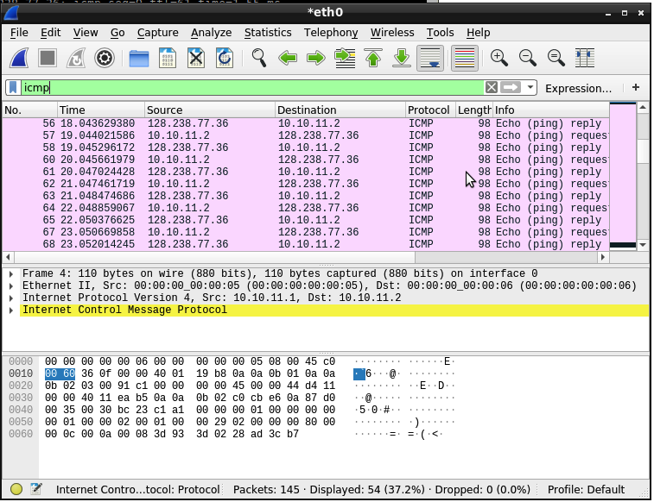

## **Wireshark screenshots on R1.**

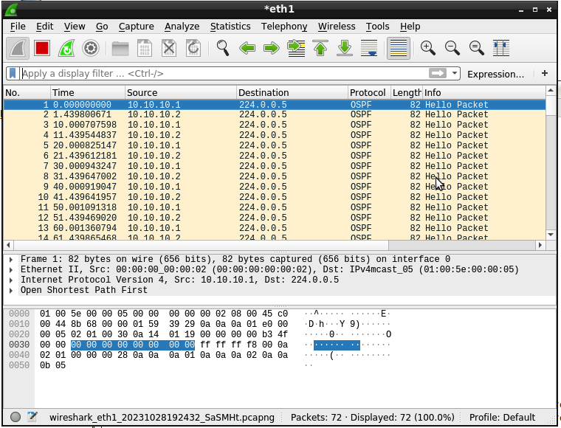

Wireshark screenshot on R1

## **Screenshots depicting successful ping requests to the SFTP server (128.238.77.36) from R1, R2, R3, and R4.**

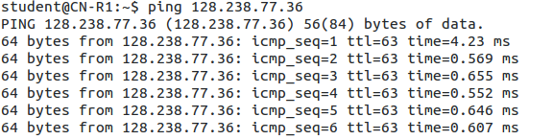

Screenshot of ping SFTP server from R1

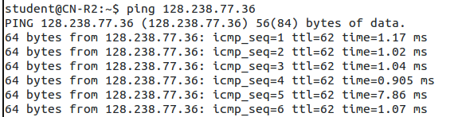

Screenshot of ping SFTP server from R2

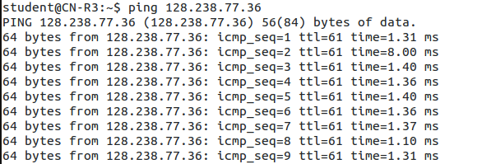

Screenshot of ping SFTP server from R3

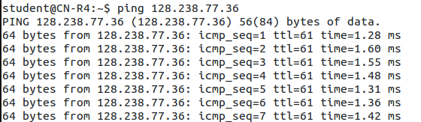

Screenshot of ping SFTP server from R4

## **Questions.**

1. **Power on all routers and run Wireshark on R1. Apply a filter for OSPF, and look at the Hello Packets. How frequently are these packets sent, and why must they be sent periodically? [10 points]**

The Router sends these OSPF HELLO packets every 10 seconds periodically according to the screenshot below.

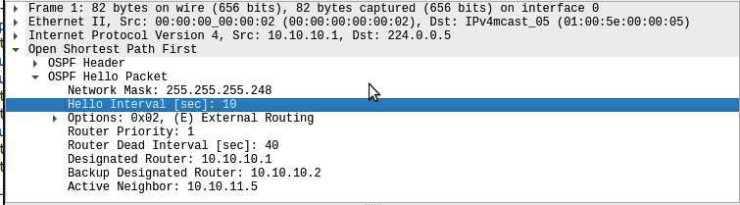

This is done to maintain neighbor relationships and ensure network stability. First, it helps routers discover and establish neighbor relationships, facilitating the exchange of routing information. Second, it allows routers to monitor the health and status of their neighbors. If a router doesn't receive Hello packets from a neighbor within a specified time, it considers the neighbor as unreachable, triggering a network convergence process to update routing tables and maintain network integrity. This periodic communication is vital for OSPF's dynamic and efficient routing operation.

1. **Continue running Wireshark and turn off R4. You should now see new OSPF packet types captured on R1. Explain why Hello, Link State Update, and Link State Acknowledgements use the same Destination IP address. [20 points]**

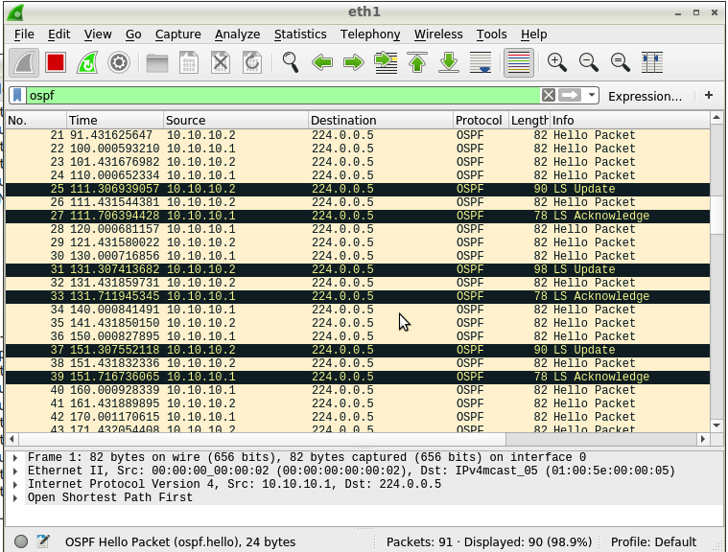

In the screenshot, the destination ip address of Hello packets, Link State Update packets, and Link State Acknowledgement packets in OSPF are same, 224.0.0.5.

Here are reasons why using the same destination IP address:

1. Group communication: OSPF routers use same destination IP address (multicast address) to efficiently distribute OSPF messages to multiple routers in a network segment.

2. Reduction of configuration complexity: Using a consistent multicast address for these different types of OSPF packets simplifies router configuration. Routers don't need to be explicitly configured to send different types of OSPF messages to different destinations. They can simply use the common multicast address for OSPF communication.

3. Minimizing network traffic: By sending Hello packets, Link State Update packets, and Link State Acknowledgements to the same multicast address, routers can efficiently exchange OSPF information without the need for separate routing entries or additional address assignments.

1. **Continue Based on the above steps, explain why we do not see DB Descriptions and LS Requests on R1. Is there a situation in which we get all OSPF packet types on R1? [20 points]**

DB Descriptions and LS Requests packets are primarily exchanged during initial neighbor setup and when there are significant topology changes. However, in this case, R1 already has a fully established OSPF network, and the initial synchronization has already occurred. So, R1 no longer needs to request or describe the database because it already has a complete and up-to-date database. We do not see DB Descriptions and LS Requests on R1 because R1 and R2 lie on the same area(area 0) and R4 router from area 1 was shut off.

# **Reference**

1. <https://www.juniper.net/documentation/us/en/software/junos/ospf/topics/topic-map/ospf-overview.html>
2. chatgpt